Monday 16th September 2024

**Buckden House – Year 6 Residential**

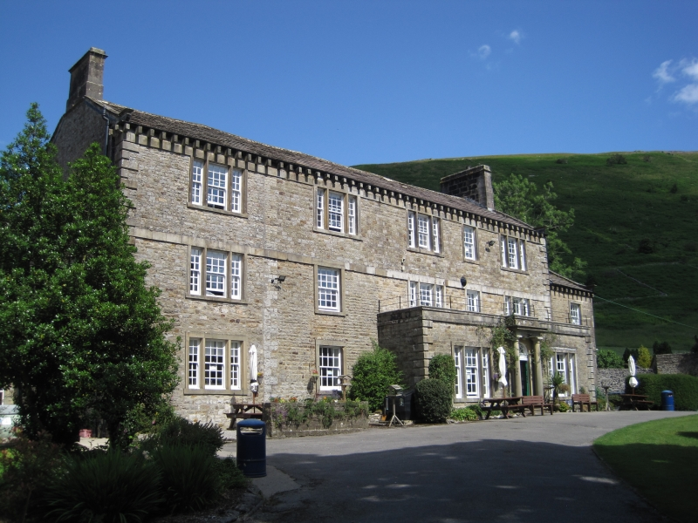

Dear Parent(s)/Carer(s),

As part of our commitment to enhancing our curriculum and providing unique opportunities for our pupils, Year 6 are invited to attend a residential at Buckden House in North Yorkshire. The aim of this residential is to give them the opportunity to take part in outdoor learning linked to the Geography and History as well as many fun sport and adventure activities.

The trip will run from **Monday 9th June - Wednesday 11th June 2025**. The cost of the trip is just **£75** and covers transportation, food, accommodation as well as the activities that we will take part in whilst we are there. A deposit of **£10** is due by the **end of October**. There are only 30 places which are strictly on a first come, first served basis and deposits should be made via parent pay.

Yours sincerely,

B Cunliffe

Mr B Cunliffe

Teacher and PE Leader

________________________________________________________________

**Buckden House – Year 6 Residential**

I give my permission for my child to attend the residential trip to Buckden House from Monday 9h – Wednesday 11th June 2025 and will pay £10 deposit via Parent Pay.

Name of Child ___________________________________Class________________

Signed Parent/Carer___________________________________________________