PEEL PARK PRIMARY SCHOOL AND NURSERY

GOVERNING BOARD
Pen Portraits

(March 2021)

Tanzila Samun
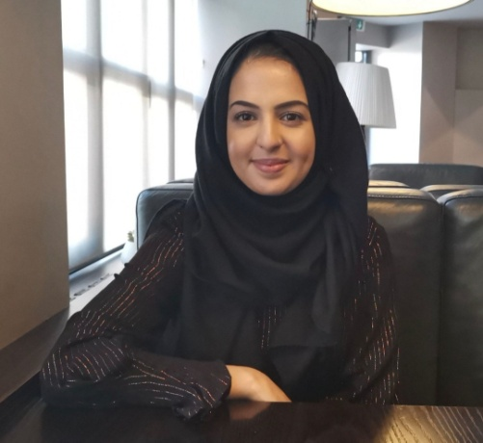
I am a newly appointed Co Opted Governor.
I am a Chartered Certified Accountant and bring with me experience in Finance within the Public Sector, along with a whole host of skills that I use in my professional life which I hope will benefit the school greatly.
I have a strong interest in education and believe that all children have the potential to achieve. I am also passionate about mental health and wellbeing and believe I can make a difference by ensuring children have the best educational start to life so that they achieve in an academic and professional setting in the future, regardless of race, colour, ethnicity or religious background.
Having grown up in Bradford, I am aware of the limitations and barriers young people experience, and I aim to represent, and to be the voice of the local community.
I enjoy reading books and in my spare time enjoy art and Arabic calligraphy. I also enjoy cooking, but I make a terrible baker!

Chris Kimberley - Staff Governor
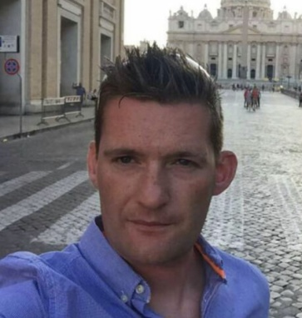
I have worked at Peel Park Primary School for over 5 years as a class teacher and then as an Assistant Headteacher. I have taught in several year groups in Key Stage 2 and supported teachers across school to improve teaching and learning. I am passionate about providing our children with the best possible education and I believe in taking every opportunity to ensure that every child reaches their full potential. My role as Staff Governor allows me the opportunity to work alongside staff, families and our community to ensure our pupils receive an enriching and inspiring curriculum tailored to the needs of our diverse community.

Mary Speight

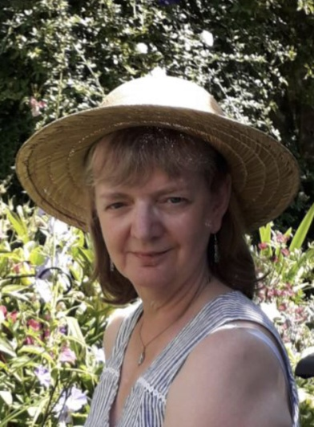
I was teacher governor at Peel Park for five years. During this time I was English as an Additional Language Coordinator, then Special Education Needs and Disability Coordinator (SENDCo) and Assistant Head for Inclusion. After retiring eight years ago I was invited to remain on the Governing Board as a community governor with responsibility at first for special needs and then, additionally, for safeguarding. Following the separation of these two roles, I continued as safeguarding governor. I live nearby, work closely with the Designated Safeguarding Lead and visit school regularly. I am a trustee of three charities, an active member of my church and a fundraiser. My other interests include art, social history, writing and editing.

Anne Newton
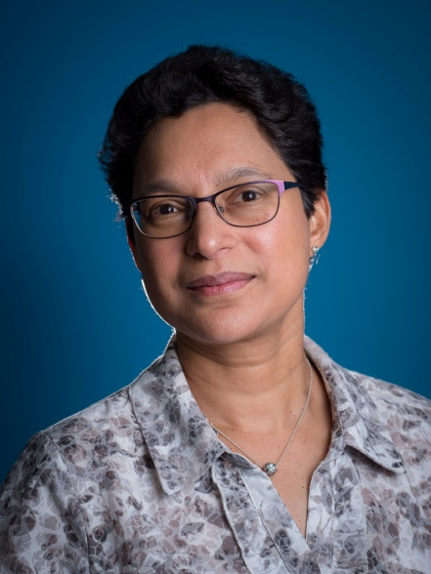
I joined the Governing Body in October 2020 and have lived and worked in the Bradford area since 1997. I have been a research scientist in the pharmaceutical industry and a clean water microbiologist, then took a 20 year break from a technical role to look after my family. I have also worked as a school business manager and am now employed as a Technical Analyst with Yorkshire Water, where I provide cost estimates that influence multi-million pound investment decisions at clean and wastewater treatment works.
My voluntary work has included listening to early readers, Year 6 practical science, fundraising as part of a women’s social group and more recently as a Bradford Community Champion and STEM Ambassador. I am keen to encourage the next generation to consider careers in Science, Technology, Engineering and Maths by supporting activities to discover and develop skills to aid future employment.
Learning is a lifelong journey, so it is important that we support that and lead by example. I am currently mentoring a young colleague new to the water industry and pushing myself to learn new skills. I am also a member of the Institute of Water Northern Area Committee and national assessor for professional development.
I love swimming, enjoy fitness classes, strategy board games and discovering new walks in Yorkshire.

Shazia Navqi (Joint Vice- Chair of Governors)
I am a parent governor and also joint Vice Chair of the governing body.
I have been a parent governor since 2013 when my eldest daughter started in reception. She now attends secondary school. My son joined Peel Park in September 2020 and is in reception class and hopefully my youngest daughter will also start at Peel Park in Sept 2021.
I work as a civil servant as well as being a qualified mental health first aider.
I feel I have the skills and experience to help build the governing body, focusing on all children and their needs within school, helping to create a healthy and happy place for all children to thrive.
I decided to be a governor as I am passionate about our community children’s education and future. I feel we all have a part to play in encouraging and bringing out the best in EVERY child and ensuring that they meet their full potential and have a great start in life.
I wanted to have a voice as a parent and wanted to make a difference for all.
I have been part of the governing body since the school came out of special measures and achieved a good school status, I hope we can continue to make a big difference to the school and get it an outstanding rating with OFSTED.
Fun Fact: I did not grow up in Bradford, I was born and raised in London and I support SPURS (COYS), I have been in Bradford now for 17 years but I’ve not lost my cockney accent yet!
If you do see me in the playground, please come and say hi.

Sarah Parker
I became a parent governor in October 2020 with both of my children currently attending Peel Park Primary School. I believe that every child is entitled to the best education available.

I also volunteer for the National Health Service supporting people with mental health issues and ensuring they can access any services required.
I previously volunteered for Action for Children and have completed several courses through Open University.

I love spending time with my children, visiting new places and taking them on holidays

Raj Unsworth - Chair of Governors

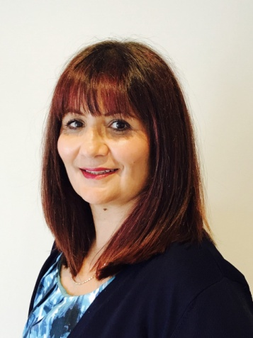

I was co-opted onto Peel Park Primary School governing body in April 2020 (during the first lockdown) and elected Chair in May. Having been a governor for 25 years I bring a wealth of experience and expertise which I intend to use to support our children, staff, parents and whole school community. I believe in the power of education to change lives and want every child at Peel Park to have a good, all round education. Our children are our future.

I am currently a member of the Pay Committee, the Headteacher’s Performance Management panel and also the Finance and Human Resources Committee.

In my spare time I enjoy running to keep fit and spending time with my family, we love cooking and eating! I’m also an avid reader and passionately believe one of the most important things we can do for children is instil a love of reading and life long learning.

Jackie Walters (Joint vice-Chair of Governors)

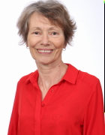

My first experience of governing was as a parent governor at my children’s school. Since then I have been a college and secondary school governor but most of my experience is in primary schools. I am chair of governors at a local primary school and as a National Leader of Governance am sometimes asked by the Local Authority to support other governing bodies.

At Peel Park Primary which I joined in April 2020 I am joint Vice Chair with Shazia, chair of the Finance and Human Resources Committee and link governor for Special Educational Needs and Disability.

I feel strongly that a good education is the right of all children and that families and schools together can support and encourage children to aim high and achieve their ambitions.

I worked in education and children’s services before retiring, both in the UK and abroad.

I enjoy being out in the fresh air, walking, running, cycling, bird watching and coaching at my running club. I also enjoy learning poetry with my Mum, reading and singing in a choir. Most of all I like to spend time with my family, especially my grand-children.

Lloyd Mason-Edwards (Ex Officio)

I have been Headteacher here at Peel Park Primary School and Nursery for 13 years. The school has changed and improved beyond recognition in those thirteen years and for the last five years we have been a 'Good' school (Ofsted). I believe that we offer our children a great start to their formative education by really tuning into the local community and their needs and providing a blend of learning with a rich and diverse curriculum that fosters enjoyment and engagement. I am proud of the staff who work here and their drive and determination to unlock every child's potential.
I am currently on one other Governing Board (where I live) as Safeguarding Governor, but have been on several other, Bradford and Leeds, Governing Boards too, over the last 7 years. I was Bradford East Headteacher Area Representative for just over 12 months.
In my spare time I like to read and am currently studying for a Masters in Political Theory. I have been the treasurer for a charity based in Cheshire (where I went to University) that raises money to send children and adults with terminal illnesses on holiday with their families, for over 20 years. I also enjoy swimming, tennis and walking in the countryside. I like to cook too but much prefer the tasting of the final product!

March, 2021.

