Peel Park Primary School Lockdown Support Guide
Useful Numbers
Food Glorious Food
Weekly school lunch packs are available to pick up from school every Monday between 12.00 and 2.00. If you would like to request one of these and have not already done so please contact Mrs Noble knoble@peelpark.bradford.sch.uk -These packs are for families who have applied and been accepted for free school meals.
If your circumstances have changed and you are finding things tough and would like some support with food please contact Mrs Noble. (See email address above)
Bradford Central Food Bank are also a useful resource 01274 734314.

Healthy Mind Healthy Body
My Wellbeing College: help for adults to manage every-day problems such as low mood, stress and anxiety – 0300 5555551.

KOOTH – an excellent mental health resource for children age 10+ www.kooth.com

https://www.camhs-resources.co.uk/websites This website provides a wealth of resources to support young people and their families.

Bradford Children’s Social Care -
01274 435600 during office hours,
use this number if you have any
concerns about the safety of a
child.
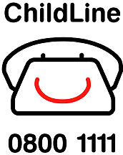
NSPCC Child Line 0800 1111

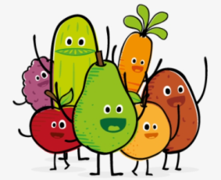
Peel Park Help Lines
Please use the following numbers if
you are having difficulties with online
learning:
Mrs Bagri for Tapestry Nursery and Reception Mon – Wed: 07466 642852.
Mrs Fox Seesaw support for Y1, 2 and 3 07404 618347
Mr Christy Wed – Fri 07404 634539 Years 4 – 6 SeeSaw technical support.

You Snooze, You Lose!
Routine is important during these difficult times.
Even though most children are not in school at the
moment it is still really important that they go to bed
at a reasonable time so they are up bright and early
for their home learning. Remember this is not a school
holiday! Children are required to complete 3 – 4 hours
of learning at home every day. Please make sure your
child engages in their learning so they don’t fall behind. Keeping Fit Competition Time!
Please also look out for our live Zoom sessions - make sure Make sure you download the home
you check your emails as further information will be court APP free onto a device.
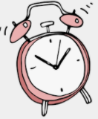
coming soon… The boy / girl with the top scores
will win a bike. Other prizes are
also available.
Always make time for your P.E. home learning!

