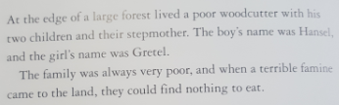

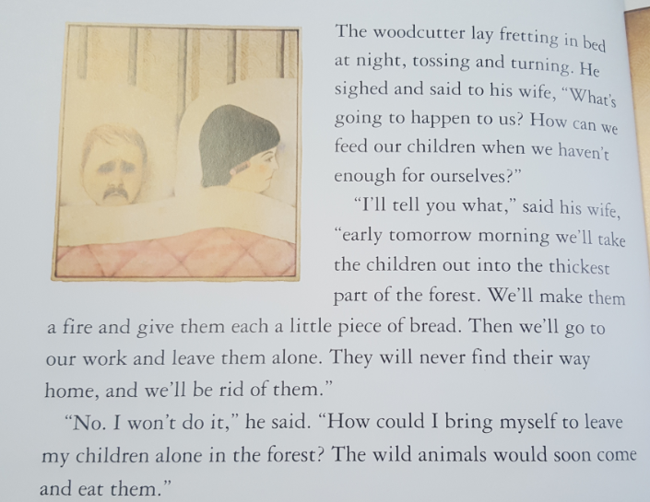

R- Where do the people live?
R- What is the name of the boy and girl?
I- Why were the family poor?
I- Why did the step-mother suggest to leave the children in the forest?
I- Is the step mother a nice person?
V- Which word/phrase in this text gives us the impression that the woodcutter is not happy about the situation?
P- The woodcutter is in a tricky situation. What will the character do next? What would you do? Why?

In a large forest, there lived a poor woodcutter, his two children and their step-mother. The boy’s name was Hansel and the girl’s name was Gretel. The family was very poor. When a terrible famine came to land and they could find nothing to eat. The woodcutter lay tossing and turning in bed. He was worried about how they would feed their children and what would happen to them. The step-mother had an idea of leaving the children in the forest all alone with a piece of bread. The woodcutter was not happy with the idea.

R- Where did the family live?
R- What were the names of the children?
R- What can you tell me about the family?
R- What came to land?
R- What was the woodcutter worried about?
R- What was the step-mother’s idea?
R- What was the woodcutter’s reaction to the idea?

