Residential
Commercial
Industrial
Transportation
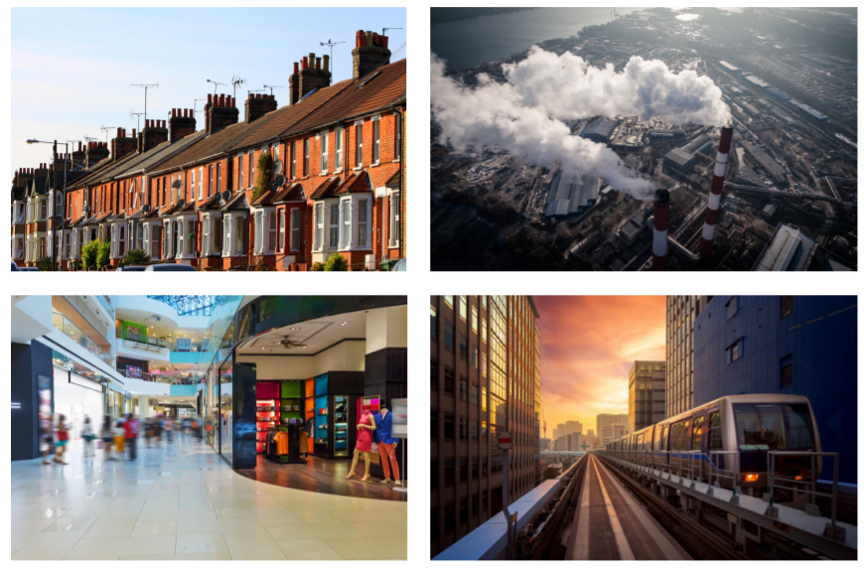

Match the correct words with the picture.

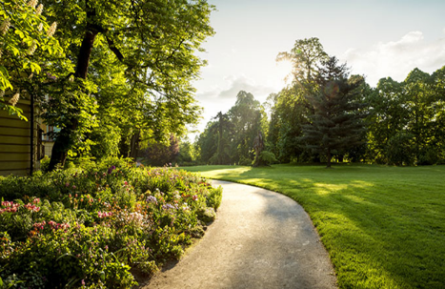
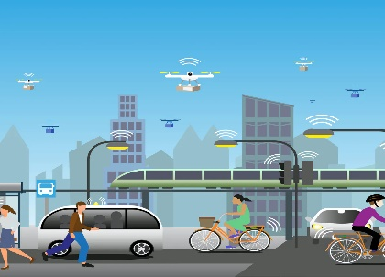
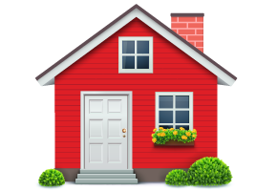
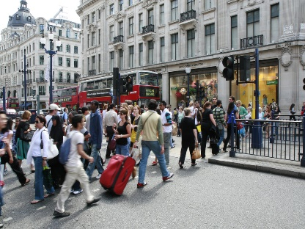
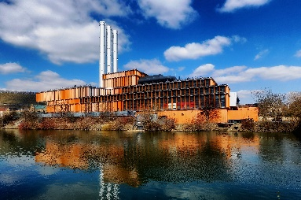

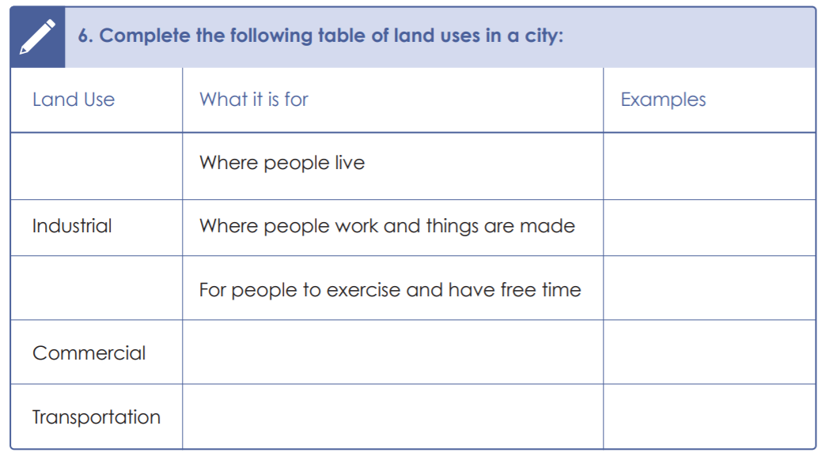
Use these words to help you fill out these boxes:
- Residential
- Factories
- Green space
- Block of flats
- Where you can travel from one place to another
- Train/bus station
- Field
- Shopping centre e.g. Broadway
- Where you can buy goods and services

