Tuesday 6th May, 2024

**Year 6: World War Two Historic Workshop**

Dear Parent(s)/Carer(s),

Linked to our history topic, World War Two, Year 6 will be participating in a themed workshop on **Monday 2nd June.** Led by the highly reputable company, Historic Workshops, children will learn about the experiences of the Blitz through engaging, hands-on activities. The workshop leader will assume the role of Chief Air Raid Warden and transport children back to the Home Front in 1939!

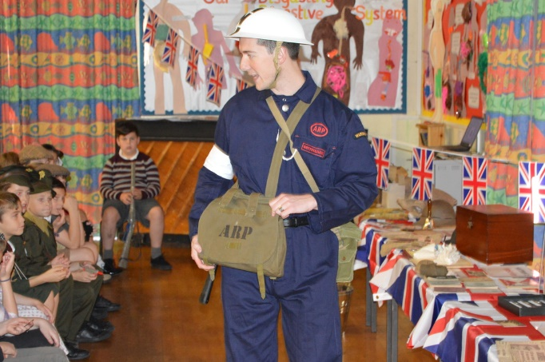

The workshop will take place at school, starting at 9.00 and finishing at 3.00. The cost of the day will be £6.50 per child. Please pay via Parent Pay by Friday 16th May 2025.

Yours sincerely,

Ms Hayer, Mrs Pollard and Miss Kirkup

Year 6 Teachers