Year 5 Home Learning – Wednesday 30th September 2020
ckimberley@peelpark.bradford.sch.uk

Maths
In our last few lessons we have reviewed everything we have learnt about place value including reading and writing numbers to 1,000,000; comparing numbers; rounding numbers and. For today’s lesson and before we return tomorrow, I want you to spend some time completing the place value tasks set on sumdog – if you complete these tasks then the house will be opened allowing you to use your rewards. I have rewarded those students who accessed sumdog with 100 coins. I have also attached some additional worksheet practice to this sheet below.

English
In English we continue with our shared writing of the second part of the story.

Reading – Room 13
Use the powerpoint to read chapter 19 from Room 13. Mr Kimberley will read the text and you can follow.

You can also practise your own reading at this website: https://readtheory.org/auth/login
You may have used this in year 4.

Guided Reading
Our guided reading lesson is focused on a video taken from literacy shed: https://www.literacyshed.com/draculas-whitby.html Watch the video and then answer the VIPERS questions. For an extra challenge complete one of these tasks:

- Write a newspaper report describing the discovery of the previously unknown crypt. (Whitby Abbey doesn't actually have one)
- Write the story as a diary or journal which abruptly ends and is completed in a different hand, perhaps the hand of Dracula himself. Include a prologue describing how and when the diary was found.
- Write the narrative through the eyes of Dracula himself, perhaps he is aggrieved at the people visiting 'his' abbey

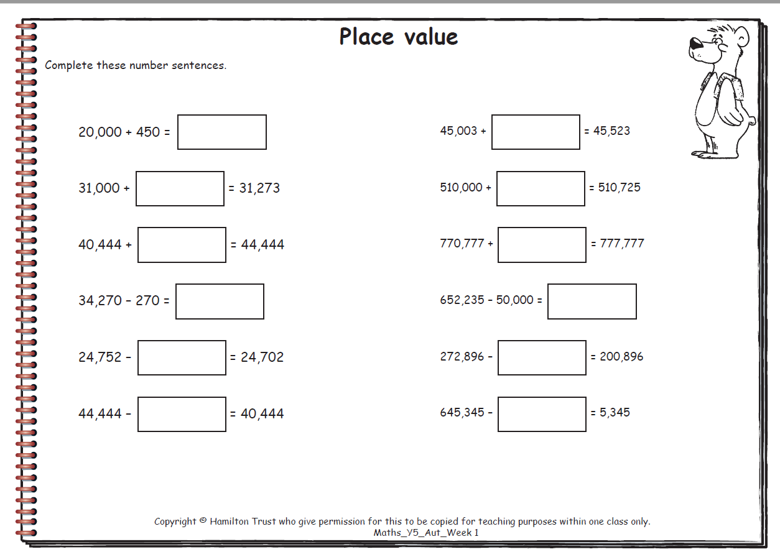
Rounding to the nearest 10
Round the numbers below to the nearest 10.
Example: 46 is between 40 and 50 and would be rounded to 50.
40
50
46

1. 43 is between and and would be rounded to
2. 57 is between and and would be rounded to
3. 72 is between and and would be rounded to
4. 85 is between and and would be rounded to
5. 103 is between and and would be rounded to
6. 146 is between and and would be rounded to
7. 148 is between and and would be rounded to

8. A company made a profit of £7,821 in one year.
What is this figure to the nearest £10?

Rounding to the nearest 100
Round the numbers below to the nearest 100.
Example: 231 is between 200 and 300 and would be rounded to 200.
300
200
231

1. 384 is between and and would be rounded to
2. 162 is between and and would be rounded to
3. 853 is between and and would be rounded to
4. 7,423 is between and and would be rounded to
5. 2,815 is between and and would be rounded to
6. 7,235 is between and and would be rounded to

7. The cost of decorating a school was estimated at £25,670.
What is this to the nearest £100?

Rounding to the nearest 1,000
Round the numbers below to the nearest 1,000.
Example: 7,852 is between 7,000 and 8,000 and would be rounded to 8,000.
7,000
7,852
8,000

1. 1,963 is between and and would be rounded to
2. 2,243 is between and and would be rounded to
3. 8,463 is between and and would be rounded to
4. 19,253 is between and and would be rounded to
5. 53,552 is between and and would be rounded to
6. 91,256 is between and and would be rounded to

7. A newspaper sold 56,792 copies.
What is this to the nearest 1,000 copies? .

