Peel Park Primary School and Nursery
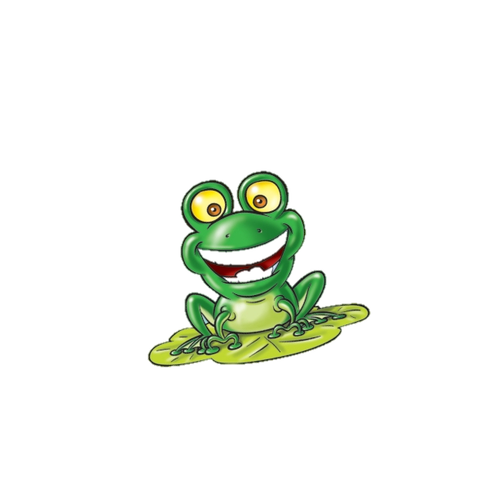
Positive Behaviour Policy
Good to be Green

Author: Mrs K Noble
Approved by Governing Body: 20.01.2021
Review Date: 20.01.2024

Equality Impact Pro-forma
Person responsible for review: | Kath Noble | Date of review: | September 2023
Groups Considered:
Race/ethnicity | ☒
Disability | ☒
Gender | ☒
Gender orientation | ☒
Pregnancy/maternity | ☒
Religion | ☒
Sexual orientation | ☒
Age | ☒
Please detail any opportunities offered by this policy to eliminate prohibited conduct, promote equality of opportunity, foster good relations or advance equalities.
None identified in an equalities context

Having reviewed the implications of any proposed changes to, or confirmation of, the policy, are there any concerns that it could have a differential impact on any of the groups identified above? Detail any steps that should be taken to minimise or eliminate any negative impact on these groups:
None identified

Policy Amendment Summary
Positive Behaviour Policy – Good to be Green
Date:
Next review date: 20.1.2023
Summary of amendments since policy introduction:
Date: | Amended by: | Details of amendment

Peel Park Primary School
Positive Behaviour Policy
Good to be Green

The Good to be Green system

Our “Good to be Green” system provides an effective way to promote positive behaviour in school. It allows for recognition for pupils who behave appropriately, while keeping track of pupils who find it harder to meet the schools behaviour code. It is a fair and consistent approach and ensures that pupils know the rules and behaviour expected in school regardless of what learning environment they are in and who is teaching them.

School Rules
- Ready
- Respectful
- Safe
We have kept the school rules clear and simple for children to remember and follow. They should see the programme as fair because it is consistent, with rewards when pupils follow the rules and a clear set of consequences if pupils do not follow the rules.
Each classroom has a Good to be Green wall chart with a space for each child. Every pupil has a green card. There are yellow cards (warning), blue stop and think cards and red cards(consequence) to be used as necessary.
The Good to be Green rules are also displayed in each classroom.
The aim is to enable pupils to stay on the green card by supporting them in following the school rules.
Effective Use of Praise
All children should experience the warm feeling of receiving regular positive feedback, yet it is important that praise is given in a meaningful way and not indiscriminately. Praise should be specific and related directly to behaviour and/or learning. Staff should make their praise sincere and accompanied by eye-contact and touch, where appropriate
Consistent Discipline
Pupils have 3 clear school rules to follow. If they don’t follow the school rules, they move onto the next step of the behaviour policy e.g. turning of their card, yellow, blue or red card. A clear set of consequences is in place for low-level rule- breaking and for more serious incidents. Use positive reinforcement “catching the being good” To achieve a consistent whole-school approach, it is essential that the procedures are followed.
Teachers should ensure that they have done all they can to help pupils with following the school rules by taking the following steps in order:
Praising pupils who are following the rules/the given instructions (in the hope that the pupil will copy their peers)
Giving the pupil a ‘gentle’ reminder – this may be verbal/non-verbal
Giving the pupil a clear instruction (with reference to the relevant rule)
Minor issues will be dealt with in class by the teacher. All adults should accept responsibility for insisting on good behaviour at all times.
All children will begin the day with a correctly turned “Good to be Green Card” If a child has a breach of the school rules the steps outlined below will be followed.
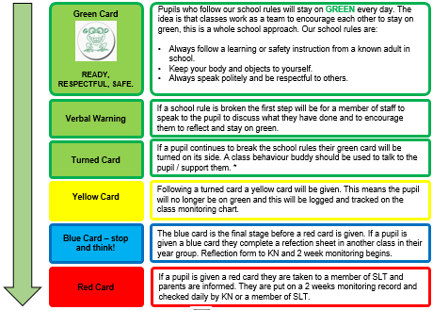
Transition around school

- Children use quiet voices when moving around school.
- Classes walk in neat, single file lines on the left hand side of corridors, stairs etc.
- Staff use lots of praise for children who are role models.
- All staff to be on board and encourage all children to follow these rules.

Lunchtime Incidents
Lunchtime supervisors will keep a record of any incidents at lunchtime and pass them on to the class teachers. The class teachers will then decide if there is a red card to be given. The child will spend the rest of lunchtime playtime in a designated area with a member of the SLT and complete a reflection sheet. On returning to class the procedures outlined above for being given a red card will be followed.

Severe Incidents
In the event of severe unacceptable behaviour children will immediately follow the procedure for a red card as outlined above.
An interview may be held with the child’s parent to discuss the need for a behaviour plan, involvement of Learning Mentor / behaviour support and where appropriate, external agencies will also be involved e.g. Educational Psychologists
Suspensions and Permanent Exclusions
The Head teacher has the right to apply a suspension at their discretion following a single serious behaviour incident. Suspensions may be applied if a child is demonstrating unsafe behaviours and / or if a child is in crisis for longer than 30 minutes with no response to any de-escalation techniques. Exclusions will only be applied where the Senior Leadership Team feel that there is no other alternative at that point in time and only as a last resort. The Head Teacher will follow the procedures outlined in ‘Suspension and Permanent Exclusion from maintained schools, academies and pupil referral units in England, including pupil movement Guidance for maintained schools, academies, and pupil referral units in England September 2022’.
The following examples are regarded as ‘serious’ behaviour incidents:
Insolence | Fighting | Lying
Racism | Biting | Insensitive/cruel behaviour
Bullying | Spitting | Stealing
Vandalism | Swearing | Absconding
Physical Violence | Verbal abuse

The list above is not exhaustive. Senior Leadership may deem any incident to be ‘serious’ if it is considered to be sufficiently severe, particularly where it compromises safety.
Peer on peer abuse – At Peel Park Primary School peer-on-peer abuse will never be accepted or dismissed as ‘children being children’. All staff in school know what to do if they come across, or are worried about, peer-on-peer abuse. They know who to speak to and what action to take to make sure children are safe. In the case of peer on peer abuse being apparent at Peel Park we will deal with it in a sensitive manner ensuring that behaviours are dealt with appropriately with support put in place if required either through school or through outside agencies.

Praise and Reward Strategies
To encourage pupils we use a range of praise and reward strategies as appropriate to the child’s age and needs. These include:
- Praise for following the school rules and/or teacher instructions
- Happy faces/beads in the jar for whole-class rewards (30 = mini-treat, 50 = mega-treat)
- Dojo points
- Sharing good news with parents at the door/in praise texts
- Weekly celebration assembly
- Use of stickers/additional behaviour charts for individuals where appropriate
- Sharing good news with other classes and adults in school
- Praise text/postcard home for good behaviour
- Rewards for children who have been Green for an academic year:
The good to be Green system is now embedded at Peel Park Primary School and works successfully for the majority of our pupils. Children are constantly praised for staying on green and this has proven to be effective. Children who remain on green for the academic year will receive a certificate and a token of recognition. They will also be placed into a draw to win a ticket to attend an event with the Head Teacher or a member of SLT. One person from each class will be drawn out.
Exemptions to Good to be Green
Whilst the Good to be Green strategy works for the majority of our pupils, we do have a number of pupils who are exempt from the scheme for a variety of reasons (at teacher’s and SLT’s discretion.) The SENDCO and Behaviour Lead will work together to form alternative plans for these children and these will be reviewed / adapted frequently to suit the individual needs of the child. Where alternative plans are in place, parents will be informed so that it can be a collaborate approach.

Mental Health and Well-being

Calming Corner – where deemed appropriate, each class to have a space in the corner of their room should a child who has a turned card need some time to sit and reflect. They take themselves to the corner with a timer and time themselves 2 minutes of reflection time to help them to stay on green. There could be a cushion to sit on, sheets with breathing exercises on them to help them regulate in the 2 minutes they are there.

Confiscation, searches, screening

If a child brings to school an item which could have the potential to cause harm to another person, the item will be removed from them. These items will not be returned to the pupils but will be returned to the parent of the child at the end of the day if appropriate. We will also remove any item which may disrupt lessons or lead to inappropriate behaviour. These items will be returned to pupils after discussion with senior leaders and parents, if appropriate.

Data

The Behaviour Lead and Head Teacher will meet half-termly to analyse the behaviour data and to discuss individual cases. Information will be reported to Governors.

